# Lab: Kanban Project - View and understand the cumulative flow diagram

­­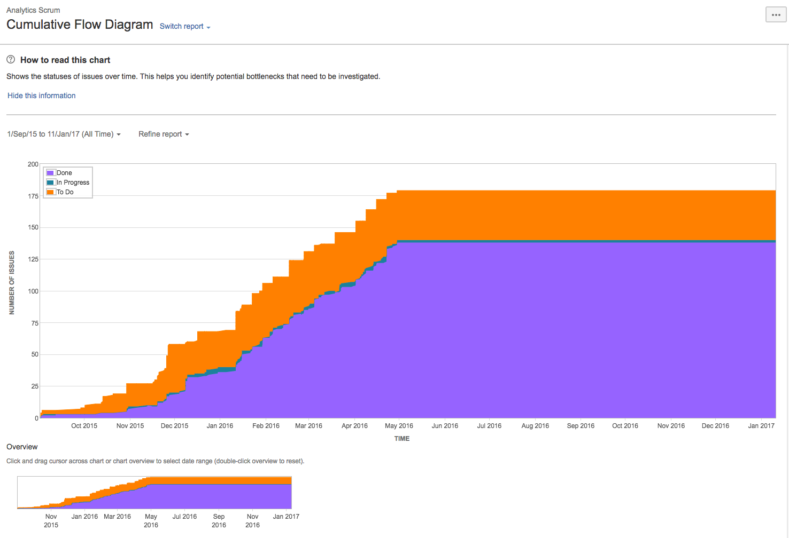

A Cumulative Flow Diagram (CFD) is an area chart that shows the various statuses of work items for an application, version, or sprint. The horizontal x-axis in a CFD indicates time, and the vertical y-axis indicates cards (issues). Each colored area of the chart equates to a workflow status (i.e. a column on your board).

The CFD can be useful for identifying bottlenecks. If your chart contains an area that is widening vertically over time, the column that equates to the widening area will generally be a bottleneck.

## **Viewing the Cumulative Flow Diagram**

1. Go to the **Kanban** **project** where your board is located, then select your **board** from the Board menu.
2. Click **Reports**, then select **Cumulative Flow Diagram**.  
   * To refine the data shown in the report, click **Refine report**, and select the desired filters.
   * To select a different timeframe, click the date range drop-down at the top of the chart.
   * To select a different date range, drag your cursor across the 'Overview' at the bottom of the chart.

## **Understanding the Cumulative Flow Diagram**

Before you start using the CFD, you should get to know how it works. The following information will help you understand its key functionalities:

* The CFD is board-specific – that is, it will only include issues that match your board's saved filter.
* It is based on your board's column mapping. An issue is considered to be 'To Do' when it is in a status that has been mapped to the left-most column of your board. Similarly, an issue is considered to be 'Done' when it is in a status that has been mapped to the right-most column of your board.
* It keeps track of how many issues are passing through each column of your board, helping you see which columns accumulate more issues than others.

For example:

1. If you start a sprint with 5 issues, all issues will begin in the **To Do** column. If you view the CFD, it will show 5 issues **To Do**, 0 issues **In Progress**, and 0 issues **Done**.
2. If you then move 2 issues to **In Progress**, the CFD will display 5 issues **To Do**(because 5 have passed through that column), 2 issues **In Progress,** and 0 issues **Done**.
3. If you then move 1 issue from **In Progress** to **Done**, the CFD will show **To Do**= 5, **In Progress**= 2, and **Done**= 1.
4. If you then take that 1 issue out of **Done** and move it back to **To Do**, the CFD will remove the 1 from **Done** and remove 1 from **In Progress,** but the numbers in **To Do** will remain the same, because no new issues have arrived. Therefore, the CFD will show **To Do**= 5, **In Progress**= 1, **Done**= 0.